California State University Long Beach
Department of Computer Engineering and Computer Science

CECS 343 Software Engineering
Review Midterm Test

Time: 60 minutes
Points: 100

Name:________________________
Student id:_____________________

Q. No. 01: Choose the correct answers. (3x24=72 points)

- Continuous user feedback is essential; feedback loops on several levels of granularity
- Agile
- Waterfall
- Iterative
- Incremental

- key challenges to software engineering are
- Coping with legacy systems
- Coping with increasing diversity
- Coping with demands for reduced delivery times
- All of above

- “Software should be written for people first” because
- Computers run the software, but hardware quickly becomes outdated
- Useful + good software lives long
- To nurture software, people must be able to understand it
- All of above

- Following is not an umbrella activity:
- Software project tracking and control
- Risk management
- Technical reviews
- Software quality assurance
- System designing

- Lockstep approach
- Spiral
- V-model
- Waterfall
- Incremental

- An important reason for requirement traceability is to track back after development and verify that all requirements have been developed, tested, packaged, and delivered.
- True
- False

- Waterfall proposes that only the strictly necessary documentation is created, with the code and unit test serving as documentation.
- True
- False

- Following is a(n) ____________________ process model.

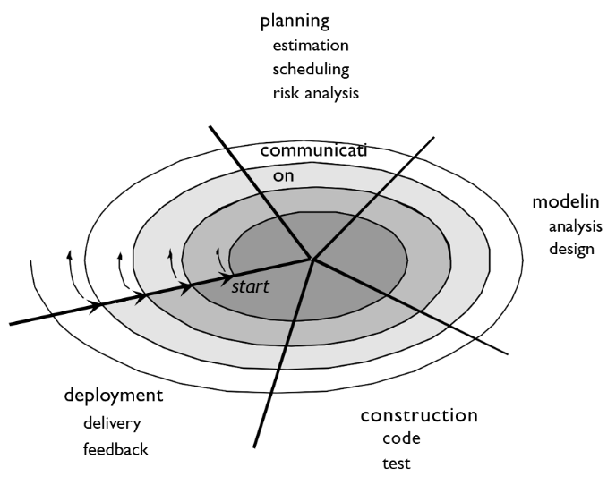
- Spiral
- V-model
- Waterfall
- Incremental

- IEEE-930 is a template for requirements specification.
- True
- False

- _______________ is defining what the system should do.
- Specification
- Design and Implementation
- Validation
- Evolution

- No fixed phases, such as specification or design, loops in the spiral are chosen depending on what is required.
- True
- False

- Business policies
- Functional requirement
- Non-functional requirement

- Define the criteria for measuring success.
- Requirement gathering
- Requirement analysis
- Requirement specification
- Acceptance testing

- Following are true about user stories except
- Preferred tool in agile methods.
- Stated in terms of user’s goals and capabilities instead of system features.
- Written by the customer or user, not by the developer.
- The development effort to implement a story is not estimated at the beginning.

- Following are standards for process assessment and improvement, except
- CMMI
- SPICE
- ISO 9001:2000
- Jira

…..
…..

Q. No. 2: Describe Agile -Scrum framework along with its activities. (14)

Q. No. 03: Describe the requirement engineering process along with its activities. (14)

